The Red Blue Divide of the United States: Applicable to PNW Region?

What are trends in demographic and economic indicators?

See graphs below, and read the printout given in class of the Brookings Institute, report, with data developed with the Wall Street Journal’s Aaron Zitner and Dante Chinni.

Here’s the 2018 Congressional Districts Map

<https://i2.wp.com/www.brookings.edu/wp-content/uploads/2019/06/2019.06.06_metro_partisan-polarization_Map.png?w=768&crop=0%2C0px%2C100%2C9999px&ssl=1>

National Map <https://www.270towin.com/2018-election-results-live/house/>

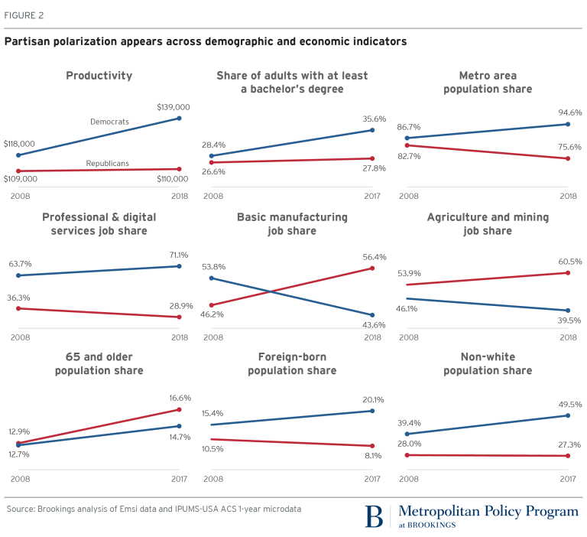

-------------

Changing Life Expectancy

<https://pbs.twimg.com/media/EKoJry8WoAAAU6E.png>

Do you think this divide also found within states where their internal demographic geography is sharply divided, such as the west-to-east divide largely defined by the Cascades for Oregon and Washington? Or Boise vs. rest-of-Idaho? Or the northern half of California with the SF Bay areas and Coast, vs. the interior rural regions?